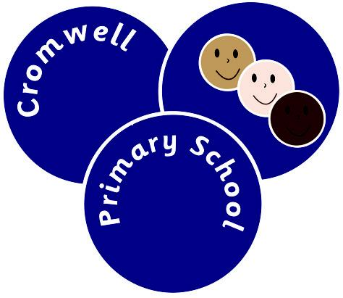

Reading for Pleasure Policy 2014.

"Schools that take the business of reading for pleasure seriously, where teachers read, talk with enthusiasm and recommend books, and where provision for reading is planned carefully, are more likely to succeed with their pupils' reading." (Ofsted)
“Children as young as 11 should be expected to read 50 books a year as part of a national drive to improve literacy standards... The vast majority of teenagers read one or two books as part of their GCSEs and [Mr Gove] said all schools should “raise the bar” by requiring pupils to read a large number of books at the end of primary school and throughout secondary education.‟ (Education Secretary)

At Cromwell Primary School the active encouragement of reading for pleasure is a core part of every child’s entitlement, whatever their background or attainment. Cromwell Primary School strongly believes that extensive reading and a wide exposure to a range of texts makes a vital contribution to every child’s educational achievement.

Reading for pleasure at Cromwell Primary School aims to establish each child as a lifetime reader based on developing a love of reading. We believe that reading for pleasure impacts on children’s futures and their life chances. According to the OECD (Organisation for Economic Co-operation and Development) ‘finding ways to engage pupils in reading may be on of the most effective ways to leverage social change’. To facilitate this we ensure our children are given a rich curriculum which encourages reading of books and other kinds of texts.

At Cromwell we aim to promote the concepts of reading for ‘fun’, ‘enjoyment’ and ‘pleasure’.

What the School does.
- Ensures there is age-related fiction and non-fiction within each class via the class book corner.
- Whole Class Novels that are read collaboratively with the adults and children throughout the school year.
- Provides newspapers and magazines (the school subscribes to First News and Aquila Magazine).
- Children have access to internet based texts which can be accessed via laptops and PCs. This includes the ‘Premier League Stars Online Challenge’.
- We celebrate children’s love of reading by ensuring book reviews are visible within school.
- Ensures reading takes place both in and outside of the classroom and in and outside of the school.
- The school encourages links with parents by ensuring every child has a Reading Journal’ that records all reading habits, signed by parents and monitored by class teachers.
- Pupil Voice is central to the school ethos, and guides the purchase of books throughout the school. Pupil questionnaires are used to gain an insight into the reading habits of the children.

Teacher’s Role.
- Teachers at Cromwell regularly read to children. Children can benefit tremendously from being read to aloud. Effective reading aloud time helps to create a positive reading experience which engages students and allows adults to model their enthusiasm for books and reading. This allows whole class interaction stopping to ask questions about what has been read or discussing the pictures they have been shown. This helps to improve pupil’s comprehension of a story.
- Actively promote books of personal interest by regularly referencing books and promoting different kinds of books.
- Provide regular time for pupils to read a self-chosen book silently. These slots are built into each class every day to allow every child dedicated time for reading for pleasure.

The School Library.
- The school library contains books from a variety of genres, by a variety of authors and covers a wide range of interest.

The Library contains the following:
Stories and narrative accounts, e.g. Fairy Tales, folk tales, and biographies.
Picture books with thought provoking images and examples of artistic talent.
Information books.
Poetry books.
Joke books.
Miscellaneous reading materials including magazines, newspapers, encyclopaedias, maps and posters.

- Children are encouraged to use the School Library to stimulate and support their reading. Every class and every child gets the opportunity to visit the library and explore books.
- Children are allowed to borrow up to two library books at all times and staff are available at lunch times to ensure children have access to the books on offer.
- Children produce a half termly newsletter promoting books and ongoing events within the library.
- Organises reading challenges including the Beast Quest/Rainbow Island book challenge.
- There is an annual budget for books to meet the demands and needs of each academic year. This budget takes into account the need to replenish and update stock.
- We ensure the library is an impressive, well used and attractive area.

To promote reading throughout the school we engage regularly in special competitions and projects, including the Radio 2 500 Words Challenge.
We have also arranged visits to independent book sellers such as Waterstones.

World Book Day and Children’s Book Weeks are celebrated annually including Author visits (Cat Weatherill and Janet Roberts).

The School subscribes to Pennac’s Invoiable Rights of the Reader. These include:
The right to read anything.
The right to skip pages.
The right to read anywhere.
The right to read aloud.

This policy, although linked to the Literacy Policy, stands alone in its promotion and encouragement of reading as a pleasurable activity and is used to engrain the School’s philosophy of a love of reading throughout life.

Review Date: July 2015

